Μετάφραση άρθρων της αγγλικής Wikipedia
στα ελληνικά
για το σκοπό του εμπλουτισμού
και της επέκτασης της ελληνικής Wikipedia

Τίτλος παραδοτέου:
Μελέτη εργαλείων αρωγής
μετάφρασης άρθρων wikipedia


Executive Summary
Wikipedia is a powerful educational and informative, community based, tool. Despite its undisputed value, though, language barriers still impend its proper diffusion. Its limited availability in Greek creates concerns about the accessibility of Greeks to its huge pool of knowledge, prompting the need for action in order to encourage community involvement in contributing Wikipedia articles in their native language. In this deliverable we will maintain that a Wikipedia translation platform needs to be developed, to enable the availability of high-quality Greek language articles by leveraging existing content from English ones. In the first section of this document the state of the art will be presented regarding available tools to implement the localization project of Wikipedia, along with the limitation these tools create. A second section will present the significant potential the customization and integration of Transifex, a translation workflow management service, with Wikipedia will create to the localization initiative of the latter. This will be followed by a detailed technical description and analysis of how such a project can be readily and efficiently implemented.
Contents
Executive Summary 3
Illustration Index 5
1 Introduction 6
2 State of the art 7
2.1 Manual processing 7
2.2 Translation tools 8
3 Translation using Transifex 14
3.1 Tools and features 16
4 Development plan 21
4.1 Project deliverables 21
5 Technical notes 23
5.1 Overview 23
5.2 Access-control 24
6 Deployment plan 25
6.1 Hosting on Transifex.net 25
6.2 Self-hosted Transifex instance 27
7 Conclusion 29
Illustration Index
Illustration 2.1: Manual processing on Wikipedia 8
Illustration 2.2: Translatewiki editor 9
Illustration 2.3: Wikibhasha editor 10
Illustration 2.4: Google Translator Toolkit Editor 11
Illustration 2.5: Google Translator Toolkit homepage 12
Illustration 2.6: Google Translate Editor 13
Illustration 3.1: Transifex homepage 14
Illustration 3.2: Transifex project overview 15
Illustration 3.3: Transifex teams list and requests overview 16
Illustration 3.4: Transifex Lotte editor 17
Illustration 3.5: Transifex Lotte suggestions box 18
Illustration 3.6: Transifex dashboard overview 19
Illustration 3.7: Transifex completion status & activity 20

Introduction
Wikipedia's teaching and informative value is indisputable. Its content can be instantly delivered to anyone, anywhere in the world with Internet access, making it a powerful educational and informative tool. Still, language barriers continue to bring challenges to the proper diffusion of the wealth of knowledge accumulated.
The number of English language articles is currently exceeding 3.5 million, making it the first language in hosted articles' number on Wikipedia. In stark contrast, Greek language articles on Wikipedia are limited to a mere 63.185. A huge pool of knowledge written in English is left untapped from Greeks not able or willing to read articles in English.
This phenomenon can partly be attributed to the lack of efficient tools which would enable Greek communities to undertake the localization task of Wikipedia.
In part, these tools appear complicated and can confuse volunteer translators with limited, or even advanced, technical skills. At the same time, these tools also present important limitations in managing the translation workflow, aiding the translation process or promoting collaboration. The result is hesitation and discouragement of the volunteering community, leading to the above mentioned poor figure.
Translation efforts need to be undertaken, in an organized and synchronized manner, and appropriate translation tools, customized to the particular needs of these efforts, will have to be applied, in order to overcome this problem.

State of the art
Efforts to localize Wikipedia in Greek have been sluggish and scattered, leaving the Greek Wikipedia considerably poor in wealth of knowledge. As mentioned above, this can be partly attributed to the fact that the available tools to translate Wikipedia have had a limited appeal to Greek-English translators and have failed to cover their needs.
Today volunteer translators can choose between manually processing an article on the Wikipedia environment itself or use a translation tool aid.

Manual processing
Manual processing is slow, error-prone and deprived of the collaborative support by the community. It usually evolves around the translators creating from scratch the article in Greek, using the English content simply as a guide. Such a requirement may impend volunteers, as it usually requires technical skills and knowledge in tasks, such as the use of special commands and syntax for editing the article, which they may find daunting, especially if they are novice users.
The outcome can lead to a slow, low-quality translation, with a negative user experience for the volunteer translators. Such outcome will then, almost certainly, generate a negative impact both to the volunteer movement and the end-users.
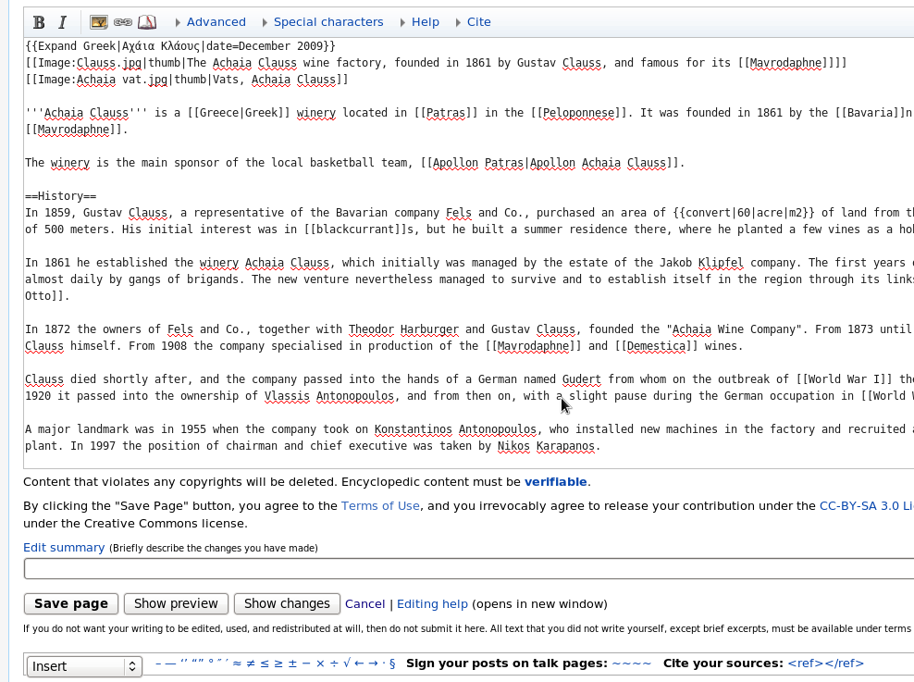Illustration 2.1: Manual processing on Wikipedia

Translation tools
The use of translation tools has improved the situation in some of the problems met in the above case but are still far from providing an efficient solution. The most popular tools used are the following:

Translatewiki
Translatewiki is a popular translation tool currently used in MediaWiki, the software underlying Wikipedia. It is a simple tool that does accelerate the process considerably compared to manual processing, but has a complicated user interface and navigation, which demands time-consuming research (especially for the first-time user), and at this time offers limited options for community collaboration support (despite being built on a wiki) and workflow management / monitoring tools.
Illustration 2.2: Translatewiki editor
Most important, though, is that it can only be used for the translation of the software that Wikipedia is built on, not the articles themselves.
Furthermore, Translatewiki, still remains at an experimental phase of development (as noted on its online documentation). This means that its code may be broken occasionally and the translation process slowed down.

Wikibasha
Wikibhasha is another translation aid tool used for the purpose of translating Wikipedia. It is a rather new tool, developed by Microsoft, which is also at an early development stage.
It acts as a user interface layer which “stays on the target language Wikipedia article that is being created or enhanced during the user-session. At the end of the session, all the additions or modifications of content are submitted to the target language Wikipedia in the updating process”.
Just like Translatewiki, Wikibhasha offers limited tools for community support / collaboration, and for monitoring and organizing the translation worflow. Moreover, Wikibhasha presents further limitations, such as:
Illustration 2.3: Wikibhasha editor
- It doesn't support working offline, creating delays and possible impediments to users who do not have continuous access to the internet.
- It doesn't segment the article into strings, forcing the translators to work on one large chunk of text, rather than segmented smaller ones which would allow them to easily view, edit or share their work.
- In essence, the users simply edit a pre-translated text of the original article by Bing Translator.
- It only allows English as a source language, restricting the material that can be translated.
- It doesn't offer built-in Translation Memory, which can considerably speed up the translation process and enable better consistency of the translated wok. What it offers is a simplified “search tool” which allows users to explore Wikipedia for relevant articles from both the source and target language Wikipedia's. These results are delivered by the default Wikipedia search mechanism.

Google Translator Toolkit
Google's rival tool to Microsoft, Google Translator Toolkit, shows a very similar interface to Wikibhasha but, also, very similar limitations. A key difference between the two is that WikiBhasha runs as an overlay within the Wikipedia interface, while the Google toolkit runs elsewhere and requires a Google account. Originally expected to function as a translation center, Google Translator Toolkit turned out to be a less ambitious product, intended less to manage a translation project but more to work as a personal translation memory tool.
Illustration 2.4: Google Translator Toolkit Editor
Important limitations found in the use of this tool are:
- Just like Wikibhasha, it instantly provides and relies heavily on the translations provided by Google Translate. This means that the users undertake the role of editors rather than that of translators.
- Its user interface provides very limited guidance, engaging the users in time-consuming research and navigation.
- It doesn't show the users a segmented text for easy translation.
- It allows limited collaboration and sharing.
- It doesn't offer users the option to write suggestions when unsure of a translation (but rather they can only add a comment).
- It offers very limited ability of workflow management and monitoring.
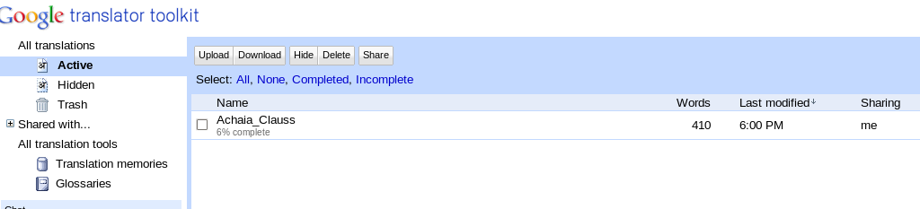Illustration 2.5: Google Translator Toolkit homepage

Machine translation
Users may also opt to use computer aided tools (CAT), either as a built-in feature of the above tools (as mentioned before) or independently. The first possibility has been mentioned above and will not be analyzed again, so we will focus on the second possibility. The most popular machine translation tool, currently, is Google Translate, but other tools are used as well, such as Bing Translator, Babelfish and other.
Machine translations produce low quality results and usually require extensive editing. For them to work best, they need to be used in combination with a translation management tool, which allows all the necessary checks before the translated material is published. Wikipedia itself, in fact, asks from users to refrain from using machine translation as a stand alone tool, with no further editing.
Illustration 2.6: Google Translate Editor
All the above methods of translating Wikipedia in Greek (and in other languages surely) have proved inefficient, creating significant difficulties to the translators, reducing their efficiency and creating a negative user experience.
In conclusion from and in addition to the above, such difficulties are:
- Time consuming and user unfriendly translation technology and workflow.
- Problems in keeping translated content up-to-date with any changes occurring in the originating article.
- Inconsistency issues with translations due to lack or limited strength of tools such as translation memory.
- Lack of a centralized tool/service to effectively manage a collaborative translation process.
These problems undermine the quality of the translated content, create lack of trust to the translated content by readers, generate scattered results and frustrate the volunteer movement of translators.

Translation using Transifex
We propose the integration between Wikipedia and Transifex, a successful translation workflow management service, to eliminate the aforementioned problems and offer a greater user experience for translators, community coordinators and end-users alike.
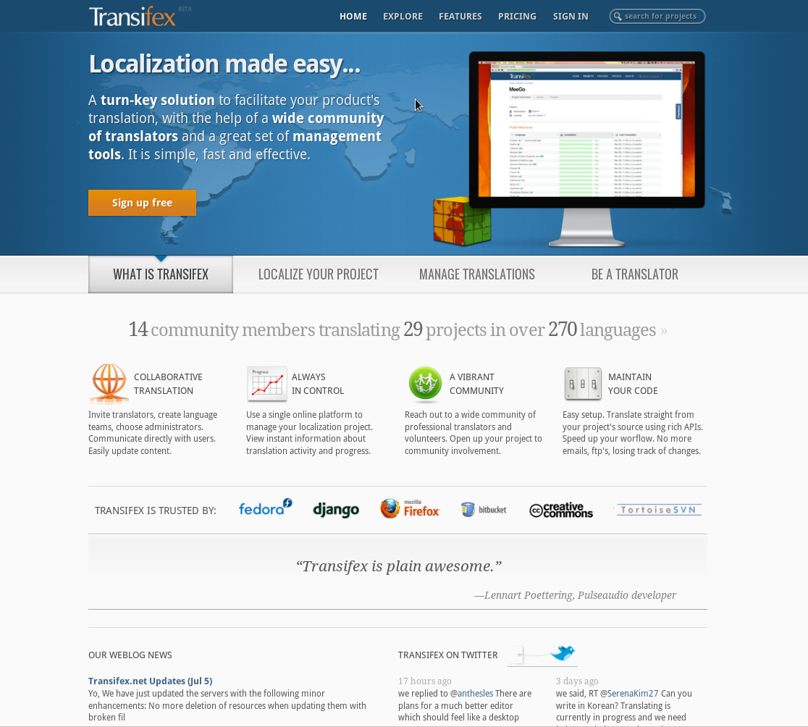Illustration 3.1: Transifex homepage
Transifex is one of the most successful open source localization platforms today, used by 1,500 projects, including Fedora, Mozilla, MeeGo and Creative Commons. It is developed jointly by Indifex and the community. It offers rich community management interfaces, APIs, and command-line tools that can improve deliverability, turnaround times, workflow management, and translation quality.
By integrating with Transifex, it is possible to 'outsource' Wikipedia's translation workflow to an external, specialized translation tool in a way that will feel integrated, natural, and intuitive to users. Translators will be able to use a powerful translation tool to help them produce quality results. By customizing Transifex to the specific requirements of Wikipedia, a solid localization platform will be available to its users.
Illustration 3.2: Transifex project overview

Tools and features
Users of Transifex have at their disposal a simple and functional user interface, with clear documentation and well organized navigation links advising them on the few simple steps they need (or have the option) to take.
Once the content for translation has been chosen, a user (called a “maintainer”) can choose to translate alone or to create translation teams, consisting of as many translators the user has decided to invite (or not) to join his project. The user can easily manage from only one to hundreds of translators, editors, reviewers etc., by assigning team administrators and coordinators, with varying levels of authority over the project.
The user can add translators or other participants to the project in a number of ways. The user may simply add translators he or she has already chosen. Alternatively, the user can visit member profile pages from Transifex's community pool and invite them to join the project. The user can communicate with these translators using the internal mailing system, visiting the Transifex forum or by posting announcements at anytime. The user may also accept requests by members, who have seen the project on Transifex or have learned about it through other means, and are interested in participating in the translation process. By these means, the user opens up the project to community participation, enhances collaboration and improves output.
Illustration 3.3: Transifex teams list and requests overview
Once the translation project has been launched, the translators can opt to translate online from their own browser (Internet Explorer, Firefox, Chrome, Fedora) using the Transifex editor, named Lotte, or offline, locally, using their own editor and upload their translated material once they are done.
When using Lotte, the content of the material being translated appears on the translators' screen segmented into strings (small phrases, sentences or paragraphs), making processing and collaboration a simplified and easy task.
The translators can follow the project's progress at all times from a board on their top left screen, showing the number and percentage of strings still remaining untranslated. From the same board, the translators can choose to have all the content's strings displayed (making it easier to understand the context of each string), or to have only the untranslated/or translated ones displayed on their screen. In any case, the translators can easily track strings that need translation, as they are accompanied by an empty box on their side (to be filled with the translation) with a red indication.
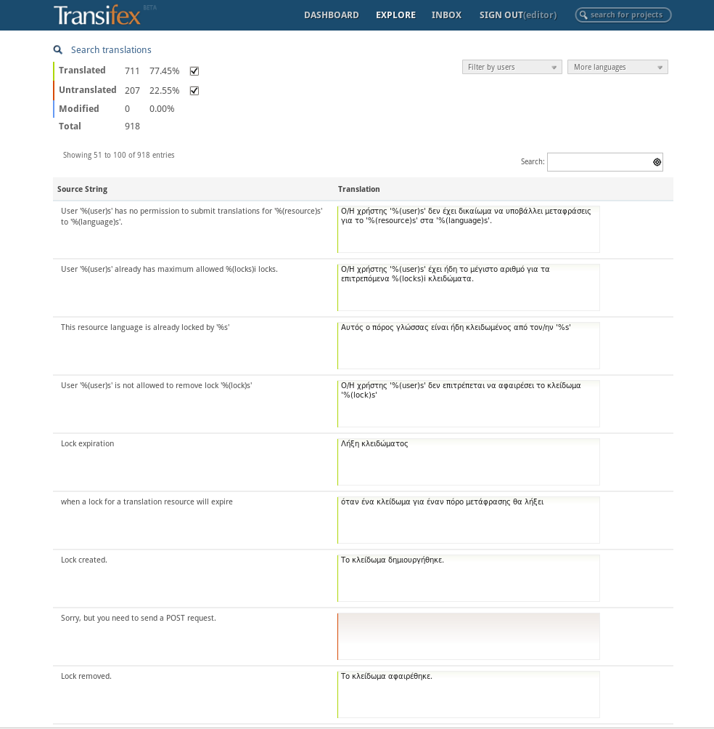Illustration 3.4: Transifex Lotte editor
For each string, the translators can be helped by suggestions created by machine translation and other translators. If the translators are unsure, they may simply write a suggestion and let the team administrator, or other, choose the best one.
Most importantly, the translators are aided by the powerful built-in translation memory Transifex has developed. This is a tool that searches the database for previous translations of the same phrase and displays the best matches. The translation memory not only saves translators valuable time but helps secure a high level of consistency in the translated material. The TM will also be made available over the API.
Illustration 3.5: Transifex Lotte suggestions box
Once the translation project has begun, the translators can lock the material they are working on, so that it is made publicly known that the particular content is being processed, avoiding, thus, duplicate work. If unwanted changes have been made to the original or translated content, the translators can always go “back in time” using the timeline feature and revert to previous versions of the content, saved on Transifex's database.
In addition, the translators may, also, set their preferences to “watch” certain content and be notified for any changes being made on that (e.g. new updated content being added which needs translating). That way they can be sure that their translated content is always up-to-date and in tune with the original content.
Users can always stay updated about the progress of their project, by using the real-time statistics Transifex offers about the status of a project. This becomes especially useful when multiple translators are used or multiple articles are being translated simultaneously, under one project umbrella, allowing users to have instant access from their own Transifex dashboard to all activity taking place, organize the workflow, monitor the progress and remain in control of the project -however small or large this is- at all times. And, once the translations have been completed, the content can be instantly downloaded, published and publicly viewed online, following a hassle-free automated process.
The above allow for the following:
Illustration 3.6: Transifex dashboard overview
- The effective translation workflow offered, with an intuitive interface specialized for translations helps recruit new translators quickly.
- Content in the original language is monitored for changes and made instantly available for translation using rich APIs.
- The built-in translation memory improves consistency and homogeneity of the translations across articles.
- Translated articles are made instantly available live for reviewing.
- Community coordinators are able to monitor a project's progress and activity in real-time, with the help of detailed statistics.
- Automated processes have replaced slow and error-prone manual tasks.
In other words, it will be possible to offer all the features found scattered in other translation tools currently used for the translation of Wikipedia, enriched with even more, on one centralized translation platform -creating a positive user experience for translator volunteers, who will be better equipped to deliver quality translations in lower turnaround times.
Illustration 3.7: Transifex completion status & activity

Development plan
The project of integrating Transifex to Wikipedia involves the development of the following components:
- Transifex Wikipedia App: The App will act as the middleware between Transifex and Mediawiki. It will be responsible for holding a list of the resources translated, monitoring the original content for updates, synchronizing translated content from and to Transifex, and holding the configuration options for the whole workflow.
- Transifex extensions to support the new markup format, translation workflow and tools to facilitate translators (reviews, suggestions, machine translation, translation memory).
- Optional Mediawiki extension to provide shortcuts for the translation workflow, such as “Translate this article” buttons, etc.

Project deliverables

Preliminary steps
- Setup of communication channels for all parties involved, agreement on project needs, technical specifications and targets
- Setup of development repository

Transifex Wikipedia App
- Publishing from Wikipedia to Transifex and vice-versa
- Page to configure workflow settings
- Conflict resolution: 'Locks' will only allow one translator to work on an article at a time.
- Translation progress notifications on Wikipedia article's discussion page

Transifex extras
- Basic parser for Wikipedia articles. Splitting is done on a paragraph level. Sentence-level segmentation will be tested, and depending on the reliability of the results might also be available.
- Availability of an account, project, access control and the necessary resources on Transifex
- Availability of new translations on the Greek Wikipedia immediately. Admin chooses whether to wait for 100% translation before the article gets published.
- Translator team management
- Web-based translation editor based on Transifex's integrated editor
- Support to first translate through machine translation (eg. using Google Translate)
- Translation memory support in translation tool.
- Ability to export translation memory to file under a CC license from the interface and the API
- User suggestion and review system on translations
- Testing – Bugfixing

MediaWiki Extension (optional)
- Links on Wikipedia articles' sidebar that provide shortcuts for users to publish content to Transifex and to navigate to the translation editor
- Automatic initiation of publishing operations on the Transifex Wikipedia App via web-hooks (special URLs on the Transifex Wikipedia App that once accessed by the MediaWiki extension and authenticated properly, initiate the publishing operations to Transifex)

Technical notes

Overview
Note: “Tx” stands for Transifex, “Wp” stands for Wikipedia and “WApp” stands for the intermediate Wikipedia App developed by Indifex.
WApp will act as the intermediary between Wp and Tx. It will be responsible for pulling content from Wp and sending it to Tx for translation. When the translation is saved/finished, it will fetch it and publish it on Wp.
WApp will also be responsible for monitoring content for changes and repeating the steps above. Past translations will be re-used when this happens, thus avoiding losing past contributions. Also, conflicts with content changes done simultaneously on English Wp, Greek Wp and Tx will be handled.
WApp will effectively take the role of the “localization manager”. WApp will communicate with Tx using the API, and authenticating using a Tx user account, similarly with how web service communication traditionally happens in web apps. These credentials (username/pass) will be saved in WApp itself, and this “robot” user account will be the owner of these data on Tx.
The user who will be administrating the service will monitor and control the procedure through a user interface on WApp. Through that interface, he or she will be able to pick which articles to pull from Wp and push to Tx. The user will also be able to manage the workflow configuration via a configuration panel.
Furthermore, public access to WApp's web interface so that unauthenticated users can pick articles to translate in a more unstructured way will be implemented. This means that there will be no pre-defined list of articles to be translated, but rather users themselves will be able to choose which articles to translate. Whether the administrator allows for this functionality will be a configuration option.
The party responsible for parsing the source content from Wp and making it available as Tx resources will be Tx, through the appropriate parser that will be developed.
Translators will be able to navigate to the content they wish to work on through Tx's web interface. This means that they will need a user account and approval by the translation manager on Tx to start working (at least until the feature to associate accounts between Wp and Tx is implemented). Access control to translators on Wp-related content will be configured with Tx's configuration panels.
The translation environment will provide a set of advanced translator services. These will include: Google translate API integration, translation-memory, translation suggestions and translation reviews.
Further automation of the process can be supported by a MediaWiki extension deployed directly on Wikipedia. Such an extension can provide links on the article page that act as shortcuts to help publish articles to Tx (through the Tx Wikipedia App) and to help users navigate straight to the translation editor on Lotte.

Access-control
Wp translation management will be done with Tx's built-in tools. Specifically, all Wp-related content will be placed under one Tx project. This project will have many resources, one for each article. Tx supports access control management for these resources and offers the following options:
- Free-for-all: Every logged in user on Tx can view and work on the strings comprising the article.
- Limited access: For each language that the project's resources are supposed to be translated to, a team is created. Only members of teams can work on the resources. A logged in user to Tx can make a team join request and the project's managers can grant him/her access. Managers are also notified by e-mail for these requests. All this process is done via Tx's web interface.
The admins of the Wp translation process can choose any option they wish, and they can also change their minds en route.

Deployment plan
The delivered service will be able to run in one of the following two ways after its completion:
- A hosted, managed Transifex service on the upstream translation hub of www.transifex.net.
- A self-hosted, self-managed Transifex service on servers provided by GRNET.

Hosting on Transifex.net
Transifex.net is currently the largest hub for open-source translations. It supports the translation of more than 1,500 open-source projects, and is being used by more than 10,000 people today.
Open source communities exist in all shapes and sizes. Some of them have a vivid translation team, but smaller ones usually depend on individual translators and usually struggle to maintain a release cycle with high-quality full-translated versions of the project. At the same time, volunteer translators rarely 'stick' with one community, and usually work with many upstream projects they like, for example MeeGo, Python, Pidgin and Transifex.
Transifex.net is an effort to build a common, upstream-like, batteries-included hosted translation hub for small and large open source projects. By bringing together the translation community in one active hive, and by automating the process of painlessly and seamlessly outsourcing the translation process and management to a web service, it has become a popular choice for many open source projects.
This model is following the successful path of similar projects. Web services like Gitorious have succeeded in hosting large and influential projects such as Nokia's Qt and Maemo. Others like Github and Bitbucket have been hosting the development repositories for thousands of open source projects.
Using the hosted Transifex.net solution has the following benefits:
- Peace of mind: Indifex is making sure Transifex is running perfectly so that the project won't have to worry about it. Projects enjoy the most stable experience by maintaining high availability servers, issuing frequent updates and instant security fixes, and taking frequent backups. No more stressful update cycles for the infrastructure: Transifex.net will be updated periodically on a weekly basis with more than 99.9% uptime.

- Predictable Costs: With Transifex.net's standard pricing packages and guaranteed SLAs, the client can accurately plan his budgeting and make sure his goals will be achieved according to plan. If in doubt, Indifex's support department can discuss the needs in greater detail.
- Lower maintenance overhead: By using Transifex.net, organizations can minimize the time and money spent in administrating their Localization infrastructure. Indifex provides dedicated engineers who manage the systems, apply upgrades and constantly improve the service, allowing customers to dedicate resources on competitive advantages and core goals rather than Infrastructure.
- Scalability: Built from the ground-up to host large numbers of projects, Transifex.net can help the localization infrastructure scale with the community's needs. The service is running on top of Rackspace Cloud, including technologies such as caching, load balancing, rich AJAX operations, asynchronous requests for time-consuming operations and distributed static file serving.
- Joining the Community: More than 1.500 projects are hosting their translations on Transifex.net, including several influential ones such as MeeGo, Fedora, Django and Mercurial. By joining the Transifex.net community of more than 10.000 users, projects can tap into an existing pool of translators, engage with the translation leaders of other projects, and recruit more contributors to the cause.
- Extra features: Additionally, Transifex.net sports a number of premium features tailored especially for large projects looking to crowd-source their translation needs, such as a new application-like Web 2.0 theme, rich user profiles and dashboard, prominent links to the project's homepage, featured projects etc.
- Immediate Access to Latest Innovations: Users of Transifex.net are experiencing the latest and greatest features as soon as they are baked from the engineering department. These include anything from extra functionality and UI improvements, to security fixes and backend improvements.
For the above reasons, this is the suggested approach for Wikipedia. A dedicated subdomain will be available such as https://wikipedia.transifex.net/

Self-hosted Transifex instance
Some projects choose to host their own Transifex instance. This allows them to exchange the aforementioned benefits for greater control over the service.
Documentation is openly available at the following resources:
- Installation instructions:
http://help.transifex.net/technical/install.html
- Running instructions:
http://help.transifex.net/technical/running.html
Here is a basic list of steps to follow in order to get a self-hosted Transifex instance running:
- Choose a Transifex version to install. The latest stable version will work nicely.
If the service is planned to run for a long-term period, it is advised to contact Indifex and arrange the maintenance of a long-term release to ensure future security updates. This has been offered widely to various large projects from Indifex's Support Services.
- Choose your hardware. By utilizing heavy caching, Transifex is allowed to run on very limited hardware resources. For the Greek Wikipedia instance, a server with 8GB RAM will suffice to handle all load of the web, database and caching servers.
- Setup the Wikipedia App in Transifex and configure it to authenticate against MediaWiki. This will most likely involve the setting of a username & password or OAuth credentials.

Maintenance
As most complex web applications, Transifex requires heavy system administration. With bi-monthly releases of stable releases, a large number of library dependencies and schema and data migration, its maintenance requires dedicated resources.
For all the above reasons, even large projects backed by large enterprises such as Fedora (Red Hat) and MeeGo (Intel, Nokia), after running their own instance for several months or years, chose to migrate to transifex.net.

Conclusion
The localization process of Wikipedia in Greek is lagging behind, not only from popular languages, such as English or German, but also compared to neighboring languages such as Italian. The Greek community of translators need to be motivated to undertake the task and participate in large numbers. The starting point of any such effort should be the provision of an efficient tool which will allow translators to deliver their work in a simple, fast and efficient manner, that will benefit both translators and end-users alike.
The poor number of articles in Greek manifests the fact that the current tools and methods have been unfit to motivate Greek translators, for various reasons. An alternative needs to be found.
Transifex, the open source translation workflow management service, can amend the limitations of the current state of the art, combine their strengths and add more features, in order to develop a customized powerful version of its platform, to fully integrate with Wikipedia and serve its users' needs.
By providing a single solution, easily accessible and understood by users of any technical skill level, and in opening up its pool of crowdsourced translators already available on its platform, Transifex will offer the necessary prerequisites to boost community participation in the localization project of Wikipedia and will help end-users enjoy a large variety of quality translated articles in Greek.

http://translatewiki.net/wiki/Main_Page
http://translatewiki.net/wiki/Project:About
http://www.wikibhasha.org/index.htm
http://en.wikipedia.org/wiki/WikiBhasha
http://en.wikipedia.org/wiki/WikiBhasha
http://translate.google.com/toolkit
http://en.wikipedia.org/wiki/WikiBhasha
http://en.wikipedia.org/wiki/Google_Translator_Toolkit
http://en.wikipedia.org/wiki/Wikipedia:Translation
https://www.transifex.net/
Django, a popular Python web framework -- http://www.djangoproject.com/
Mercurial, a popular distributed versioning sytstems available -- http://mercurial.selenic.com/

