Μετάφραση άρθρων της αγγλικής Wikipedia
στα ελληνικά
για το σκοπό του εμπλουτισμού
και της επέκτασης της ελληνικής Wikipedia

Τίτλος παραδοτέου:
Transifex – Wikipedia Integration Configuration Guide


Executive Summary
Wikipedia is a powerful educational and informative, community based tool. Transifex is a community collaboration tool to ease the translation of content to various languages. Using Transifex, Wikipedia users could collaborate to translate original content from the English Wikipedia to the other Wikipedia and enrich the number and quality of their articles.
So, we developed an application which integrates Wikipedia with Transifex. This is a Trasnifex app, which acts as the middleware between Transifex and Wikipedia and is responsible to synchronize original content from the English wikipedia, translations in Transifex and the translated articles in the Greek Wikipedia.
This document describes the architecture of the system, how to install and configure it and how to use it.
Contents
Executive Summary 3
1 Introduction 6
2 Software deliverables 7
3 Implementation 9
3.1 Architecture 10
3.2 Implementation 11
3.3 Configuring Transifex Wikipedia Application 14
4 Installation 15
4.1 WApp 15
4.2 Transifex 17
4.3 Serving a django application with Nginx 18
5 User Guide 22
5.1 Project owner 22
5.2 Translators 25
Illustration Index
Illustration 2.1: Architecture of Wikipedia - Transifex integration. 8

Introduction
This document describes an implemented way to integrate Wikipedia with the Transifex. The significance of this integration lies to making content accessible to the non-english-speaking users of Wikipedia, specifically to the Greek users of Wikipedia.
The goal of this integration is to provide the ability to Wikipedia users to collaborate on translating original articles found in the English Wikipedia. Transifex provides excellent tools to ease the process of translations and its workflow, like an online translation editor and support for translation teams.
We provide any user the ability to register any articles from the English Wikipedia to Transifex. Then, as soon as the article is fully translated, it is sent to the Greek Wikipedia. Any updates taking place in the original English article are pushed to Transifex for translation and, as soon as they are ready, to the Greek Wikipedia.
To make this integration easier, we create a Transifex Wikipedia application. This application handles the synchronization of the English Wikipedia, Transifex and the Greek Wikipedia. Additionally, we added new functionality to Transifex to make it able to handle mediawiki markup text and make the process of translating specifically Wikipedia articles easier.

Software deliverables
The software that was developed for integrating Transifex and Wikipedia is:
- The transifex-client-library, which is a library that provides a wrapper around the API of Transifex.
- The txapp framework, which is a framework specifically designed to make applications for Transifex easier.
- The wikipedia project, which uses the txapps framework to implement the actual integration of Transifex and Wikipedia.
- The txapps add-on for Transifex, which adds the functionality to Transifex to communicate with a txapp application.
- The webhooks add-on for Transifex, which adds the functionality to Transifex to visit a URL whenever a translation is updated in Transifex.
- A reviewing system for Transifex, which adds the ability to project owners to review and accept translations. The respective changes were developed as an integral part of Transifex and can be found at https://bitbucket.org/indifex/transifex, specifically changesets
  - 8bc2acdcf248
  - 331c09368f77
  - 1b35ee015bb1
  - c5f7e7f0d732
  - b5e74c0deda1
  - c3a486d8819f
- A parser for mediawiki markup.
- A new API.
- A suggestions system for lotte, the online translation editor Transifex uses.
as well as various smaller changes in Transifex, which were made to ease the translation process of a project both for the project owner and the translators.

Implementation
In this section we describe the architecture of the system developed and the way it integrates with the English Wikipedia, the Greek one and Transifex. We also discuss the changes that were made to Transifex to make this integration possible.
In general, there are four systems that communicate and exchange data. There is the English Wikipedia, the Greek Wikipedia, Transifex and the Transifex Wikipedia application. From now on, we will refer to the Transifex Wikipedia Application as WApp. WApp is the mediator among the three other systems and is responsible to seamlessly make them work together.
In the following we also refer to a few terms. These are:
- An article. The article is content published in Wikipedia under a URL.
- A resource. The resource is a translation unit defined in Transifex. It could be an article from Wikipedia, a blog post or a po (gettext) file.
- A project. A project is defined in Transifex. It refers to a translation project as a whole. For example, a software program could be a project in Transifex or a series of posts from the same blog.
- A web hook. A web hook is a combination of events, monitoring for those events and visiting a URL as a result of one of those events being emitted. Web hooks are used to avoid polling processes. That is, when we want to be notified, when an event occurs in a system like Transifex, instead of polling the system constantly and consuming resources as a result, we register a URL callback and instruct the system to notify us, whenever the event we are interested in occurs.

Architecture
As we have already said, there are four systems at play. There is the English Wikipedia, which has the original content, the Greek Wikipedia, which has the translated content, Transifex, which manages the translation process, and WApp, which is coordinates the other three systems.
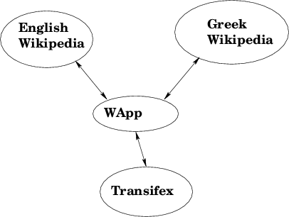Illustration 3.1: Architecture of Wikipedia - Transifex integration.
The relationship among the four subsystems is shown at illustration3.1. The most important role is the one that WApp has; it is responsible to synchronize and instruct the other three systems. Specifically,
- It pulls articles from the English wikipedia and pushes them to Transifex.
- It waits for the articles to be translated in Transifex and pushes them to the Greek Wikipedia.
- Whenever an article (among those handled by WApp) is updated in the English Wikipedia, the updates are pushed to Transifex and, as soon as they are translated, they are sent to the Greek Wikipedia, so that it always has the latest fully translated version.
- If an article (among those handled by WApp) is manually edited in the Greek Wikipedia, it is considered to be an independent article and the orignal article stops being watched for updates from WApp.
Transifex, on the other hand, manages the translation process itself. Anyone can register in Transifex and help translate content from Wikipedia. The Wikipedia project owner can create translation teams and accept specific users, instead of allowing anyone to translate articles in Transifex. He could choose to do that in order to increase the quality of the translations, since he opens translations only to trusted users. The project owner is also given the option to appoint reviewers, who check and accept a translation, only if it is of high quality.

Implementation
Both Transifex and WApp are written in the Python programming language and use the django web framework.

Transifex
Transifex is a well-known translation management platform which is being developed for a few years now. However, in order to support the integration with Wikipedia, there were a few changes and some new features necessary.
An API has been developed to allow the creation of resources and the pushing and pulling of translations of those resources. This API is RESTful (see http://en.wikipedia.org/wiki/Representational_state_transfer) and, compared to the earlier API, allows to exchange the content as JSON encoded strings instead of as files. This was necessary, since we exchange the content of an article between Transifex and Wikipedia and creating intermediate files is unnecessary and time-consuming. Moreover, the new API has better performance and is much richer and consistent.
Another new feature for Transifex is the support for defining web hooks. Web hooks allow to avoid constantly polling Transifex for changes in the resources of a project; instead, Transifex notifies us as soon as a translation of a resource has changed. This helps to keep network and CPU usage lower.
Additionally, a new parser for mediawiki markup has been added to Transifex. This parser reads the original content and tries to split it to smaller parts. This is necessary, since it is much easier to translate an article in smaller parts than as a whole. This allows for collaboration of translators, too, because they can work simultaneously on different parts of an article. It was decided to split articles to paragraphs and not sentences. This was done, because in this way the translator has more freedom to choose how he should translate the original content; there is reason why we should enforce a one to one mapping between English and Greek sentences. Of course, we take into account the templates used by Wikipedia and do not split inside one.
Furthermore, we have added a new system to support reviewing translations. This helps increasing the quality of translations. It is up to the project owner to put some people in charge of reviewing of translators.
Moreover, Transifex has been updated with a series of changes to further facilitate the process of translating content. Among those changes is the ability to show more detailed statistics and enabling translators to add suggestions for an original translation part. Suggestions are necessary to ease the collaboration of translators; a translator can suggest a translation for a paragraph in case he is not certain for it, instead of committing it as translation.

WApp
In order to make the integration of Transifex and Wikipedia easier, we have developed a separate application to manage the whole process. This was necessary, in order to avoid complicating the Transifex and Wikipedia codebases. It also has the advantage that the WApp can be developed separately from Transifex and mediawiki, the software behind Wikipedia. WApp communicates with Transifex and Wikipedia only through their respective APIs. So, as long as the APIs are stable, the application itself is independent of any development of Transifex and Wikipedia and, respectively, Transifex and Wikipedia are independet of the development of WApp. This decision has already proved itself during developing WApp.
WApp uses a library of Python bindings around the API of Transifex. Using the higher-level bindings makes using the API much easier, faster and more robust. Additionally, we have developed a framework to create Transifex applications. This framework provides common functionality to WApp. The framework defines a protocol which defines how the configuration and other pages WApp needs are shown within Transifex, so that everything is set up from within Transifex.
WApp uses the API that mediawiki defines to pull content from the English Wikipedia and push it to the Greek Wikipedia. It does not need to login to the English Wikipedia; instead it fetches content as an anonymous user. On the contrary, it uses a previously defined account to push articles to the Greek Wikipedia, so that there is a full record of the actions of Wapp.
WApp also uses the Transifex's API to push/pull translations. It uses the API to create a new resource for each article, to push any updates to the resource and pull any translations. There is also a web hook defined in Transifex, which notifies WApp as soon as a translation has been updated.
The functionality of WApp is the following:
- Whenever an article is added in Transifex, WApp pulls the content of the article from the English Wikipedia, creates a resource in Transifex and sets its content to that of the article. The article is also added to its list of tracked articles.
- Once the article has been fully translated, WApp pulls it from Transifex and creates the corresponding article in the Greek Wikipedia, adding a comment in the discussion page of the article that the article is translated by Transifex.
- WApp constantly monitors the English Wikipedia for changes in the tracked articles. If it finds one, it pulls its content and pushes them to Transifex. The mediawiki markup parser will split the updated content to parts and update the corresponding resource. It is worth noting that, if a part has not been changed at all, any existing translation will be kept. Additionally, if the old and the new part are very similar, the previous translation (if any) is set as suggestion for the specific part.
- Whenever an updated resource is fully translated, the updated translation is pushed to the Greek Wikipedia.
- If one of the tracked articles is changed manually (outside of Transifex) in the Greek Wikipedia, then WApp stops tracking it; the article is considered independent from the original one. The corresponding resource is removed from Transifex, too.
WApp uses celery (see http://celeryproject.org/) as a message queue. Celery allows to offload work to another process, so that the main proecss remains responsive. That is, we define a set of jobs and can initiate one in another process, when a request arrives. So, the main process that handles the request is more responsive, which is crucial for a web apllication in order to handle a lot of requests. Specifically, we use celery to schedule jobs, so that they are executed periodically. That is, the English and Greek Wikipedia are checked periodically for changes. Also, any update in translations in Transifex or edit of a tracked article in the English or Greek Wikipedia is noted and the actual response to these updates are made also periodically, in batch. We choose to scheduling the available jobs instead of executing them as soon as a signal is arrived, so that we can work around any API limitations as far as the allowed rate of requests are concerned and so that we can handle the load much better.
The available tasks/jobs defined are:
- fetch_new_articles, which retrieves newly added (in Transifex) articles from the English wikipedia.
- check_for_manual_edits, which checks the tracked articles in the Greek Wikipedia for any edits that took place outside Transifex, i.e., manually. In such a case, it marks them for deletion.
- delete_unwatched_articles, which deletes marked for deletion articles from Transifex.
- check_for_updates, which checks the tracked articles for any updates in the English Wikipedia. If that is the case, it marks the article as updated.
- get_updates, which fetches articles that are marked as updated from the English Wikipedia and pushes them to Transifex.
- get_translation, which pulls the translated article from Transifex and puts it to the Greek Wikipedia. The article is marked as translated, when WApp is notified by Transifex through the web hook.
The time intervals on which these jobs are run are configured in a settings file of the project. So, the project owner may choose the ones he wishes, depending on the load he has and on the response times he wants to achieve.

Installation

WApp
There are three pieces of software needed to have the application running:
- The transifex-client-library library, which has the Python bindings around the Transifex API.
- The txapp library, which is the framework that has the main infrastructure needed to create an application for Transifex.
- The wikipedia project, which has the actual code for the Transifex Wikipedia application.
The transifex-client-library/txlib, txapp and wikipedia directories must be importable by Python. So, the directory that contains them must be added to the Python path.
There are many ways to do that. A simple and effective way is to use the virtualenv and virtualenvwrapper programs. The first one creates a Python virtual environment. The second one provides bash shell functions to manage virtual environments more easily.
First of all, one needs to configure virtualenvwrapper. The documentation for the latest version is at http://www.doughellmann.com/docs/virtualenvwrapper/. One basically needs to set the variable WORKON to a directory he wants to save the virtual environments he creates. To do that, he must add the line
export WORKON_HOME=~/.virtualenvs/
source /usr/local/bin/virtualenvwrapper.sh
to his .bashrc file and issue the command
source ~/.bashrc
to activate the change to his environment. Then, he needs to create the directory with the command
mkdir -p $WORKON_HOME
After configuring virtualenvwrapper, one must go to the directory where he will host the code and execute the following commands:
mkvirtualenv --no-site-packages --distribute wikipedia
to create a virtual environment and
workon wikipedia
to activate it. Then,
pip install django==1.3.1 south celery django-celery \ mwclient requests django-picklefield
to install the necessary dependencies. At this point, one must decide on which how to setup celery. There are detailed guides with the available options at http://docs.celeryproject.org/en/latest/getting-started/broker-installation.html and http://docs.celeryproject.org/en/latest/tutorials/otherqueues.html. The code as shipped is configured to use the database backend only because it works out of the box. The recommended one is RabbitMQ and, perhaps, Redis. But that is up to the administrator to decide and configure. Whatever backend is used, it requires the installation of extra packages. For example, the default setup that uses the database backend requires to install the packages django-kombu and kombu using pip install.
As soon as the virtual environment is ready, one needs to execute the following commands:
mkdir -p /srv/wikipedia_project/
cd /srv/wikipedia_project/
cp -a /path/to/transifex-client-library/txlib/ .
cp -a /path/to/txapp_repo/ .
cp -a /path/to/wikipedia_repo/ .
add2virtualenv .
At this point one must configure the actual application, as described in the next section.

Configuring Transifex Wikipedia Application
WApp comes with a set of configuration options, that the administrator must setup, before using the application.
All options reside in the file wikipedia/settings.py. At least the following variables must be setup.
- ADMINS, where you put a list of the administrators of the application. This is used, for instance, to notify them by email when an error occurs.
- DATABASES: It is advised to use the PostgreSQL database.
- SECRET_KEY: Put a random key to use for encryption issues.
- TEMPLATE_DIRS: Put the path to wikipedia/templates/.
- TX_URL: The URL that Transifex is running at.
- WP_PROJECT_SLUG: The slug of the project at Transifex, where the translations for the articles from wikipedia take place.
You can of course use any other options among those django supports. These are extensively documented at https://docs.djangoproject.com/en/1.3/ref/settings/.

Initializing and Running Transifex Wikipedia Application
Once the application has been configured, we must initialize the database issuing the commands:
python manage.py syncdb && python manage.py migrate
Then, one can follow one of the many solutions to deploy a django project, using, e.g., apache and mod_wsgi or nginx and gunicorn or uwsgi.
Finally, one must enable celery to run as daemon, in order to execute the jobs periodically. Detailed instructions are given at page http://docs.celeryq.org/en/latest/cookbook/daemonizing.html.
We use the supervisord approach. Install supervisord with the command
apt-get install supervisord
for a debian - based system. Then, navigate to the directory /etc/supervisor/conf.d/ and create the file celeryd.conf with the following contents:
[program:celery]
command=$VIRTUALENV/wikipedia/bin/python \ /srv/wikipedia_project/wikipedia/manage.py -B -l INFO
directory=/path/to/wikipedia_project/wikipedia
user=nobody
numprocs=1
stdout_logfile=/var/log/celeryd.log
stderr_logfile=/var/log/celeryd.log
autostart=true
autorestart=true
startsecs=10

; Need to wait for currently executing tasks to finish at shutdown.
; Increase this if you have very long running tasks.
stopwaitsecs = 600

; if rabbitmq is supervised, set its priority higher
; so it starts first
priority=998
where VIRTUALENV is the path to the virtual environment we created before, i.e., $WORKON_HOME/.

Transifex
There are detailed instruction to install Transifex at http://help.transifex.net/server/install.html#installing.
As soon as Transifex has been configured and is up and running, one needs to create a project that will host the resources for the Wikipedia articles. All translation jobs will be done from within that project. The slug chosen should be the same as the one used in the WP_PROJECT_SLUG setting in the application, as described in the previous section.
Then, you need to go to the /admin/ path in Transifex (like http://mytransifex.net/admin/) and navigate to the Tx apps section, where you need to create a new txapp. You should set the field slug to wpapp and the field URL to the URL of WApp.
After adding Wapp to Transifex, one needs to go to the page of the project and add the path /apps/ at the end (like http://mytransifex.net/projects/p/wikipedia/apps). At that page one must enable Wapp for his project. Wapp must already be running, so that the current project is registered to the application.
After that, one must set the credentials used to authenticate against Transifex and the Greek Wikipedia. To do that, he must go to the path /projects/p/<project slug>/apps/wpapp/overview/, which is the overview page of the application, and set the credentials for the account for the Greek wikipedia (which will add and update articles) and those for the account for Transifex (which will create/update the resources in Transifex for each article).
From the overview page the project owner can also add a new article that he wishes to translate and list articles which are being translated in Transifex. It is worth noting that anyone registered in the specific project (like maintainers and team members) may access these two pages. If one wants to enable these pages for them, he must execute the command
python manage.py shell
and then execute the commands
from txapps.models import TxApp
app = TxApp.objects.get(slug='wpapp')
app.team_allowed = ['add_article', 'list_articles', ]
app.save()

Serving a django application with Nginx
In this section we provide general instructions on how to serve a django application using Nginx.
Nginx is a well-known and very fast web server. In the following process we use the fcgi protocol, which is one of the standard and proven ways to serve (not only) a django application.

Nginx
Nginx is the web front-end that handles the HTTP connections and forwards them to the Django application. By default it listens only on port 80.
First, one needs to install nginx. On a debian-based system this can be done by issuing the command
apt-get install nginx
The server configuration resides in /etc/nginx/nginx.conf. The content of this file should be:
user wikipedia;
worker_processes 2;
error_log /var/log/nginx/error_log info;

events {
worker_connections 1024;
use epoll;
}

http {
include /etc/nginx/mime.types;
default_type application/octet-stream;

log_format main
'$remote_addr - $remote_user [$time_local] '
'"$request" $status $bytes_sent '
'"$http_referer" "$http_user_agent" '
'"$gzip_ratio"';

client_header_timeout 10m;
client_body_timeout 10m;
send_timeout 10m;

connection_pool_size 256;
client_header_buffer_size 1k;
large_client_header_buffers 4 2k;
request_pool_size 4k;

output_buffers 1 32k;
postpone_output 1460;

sendfile on;
tcp_nopush on;
tcp_nodelay on;

keepalive_timeout 600;

ignore_invalid_headers on;

upstream backend {
server 127.0.0.1:8080;
}

server {
listen 80;
server_name _;
client_max_body_size 20M;
root /path/to/wikipedia_project/wikipedia/;

send_timeout 600;
proxy_read_timeout 600;
proxy_connect_timeout 600;

location / {
# For maintenace page.
if (-f $document_root/maintenance.html) {
return 503;
}

fastcgi_read_timeout 600;
fastcgi_pass backend;
fastcgi_param SERVER_NAME $server_name;
fastcgi_param SERVER_PORT $server_port;
fastcgi_param SERVER_PROTOCOL $server_protocol;
fastcgi_param PATH_INFO $fastcgi_script_name;
fastcgi_param REQUEST_METHOD $request_method;
fastcgi_param QUERY_STRING $query_string;
fastcgi_param CONTENT_TYPE $content_type;
fastcgi_param CONTENT_LENGTH $content_length;
fastcgi_pass_header Authorization;
fastcgi_intercept_errors off;
fastcgi_param REMOTE_ADDR $remote_addr;
}

error_page 503 @maintenance;
location @maintenance {
rewrite ^(.*)$ /maintenance.html break;
}

access_log /var/log/nginx/nitro.access_log main;
error_log /var/log/nginx/nitro.error_log;
}
}
After configuring nginx, one must restart the server process with the command
sudo /etc/init.d/nginx restart

Supervisor & FastCGI
Supervisor is a process control daemon. It is used to manage the FastCGI processes serving the wikipedia application.
sudo apt-get install supervisor
sudo /etc/init.d/supervisor stop
The supervisor configuration goes in /etc/supervisor/conf.d/wikipedia.conf
and should be:
[program:wikipedia]
command=$VIRTUALENV/wikipedia/bin/python \
/path/to/wikipedia_project/wikipedia/manage.py runfcgi \
host=127.0.0.1 port=8080 maxchildren=8 maxspare=10 \
minspare=5 maxrequests=200 method=prefork \
errlog=/var/log/flup/error.log \
outlog=/var/log/flup/out.log \
pidfile=/var/run/supervisor-fcgi.pid \
daemonize=false
directory=/path/to/wikipedia_project/wikipedia/
environment=PYTHON_EGG_CACHE='/tmp',LANG='en_US.UTF-8'
user=wikipedia
numprocs=1
autostart=true
autorestart=true
startsecs=10
Now that everything is set up the application servers can be started.
/etc/init.d/supervisorstart
supervisorctl start wikipedia

User Guide

Project owner
Transifex comes with a a user guide for project owners. It is hosted at http://help.transifex.net/intro/projects.html#user-projects.
The project owner can add maintainers to the project and create teams. He (along with the maintainers) is responsible to add users to a team upon request.
The project owner is also the one who will mainly interface with the extension. A screenshot of the overview page of the extension is shown in illustration 5.1. From the overview page, he can add articles (the exact URL is http://<transifex-url/project/p/<project-slug/apps/wpapp/add_article/) and see a list of the translated articles (the exact URL is http://<transifex-url/project/p/<project-slug/apps/wpapp/list_articles/).
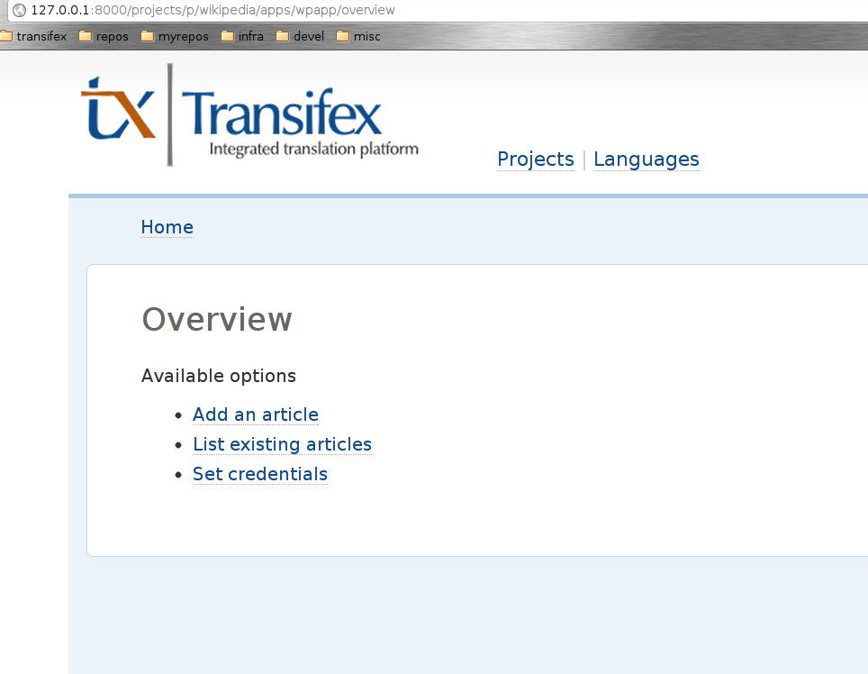Illustration 5.1: Overview page.
As far as adding a new article for translation is concerned, the user must enter the URL of the English article and the desired URL in the Greek Wikipedia. Illustration 5.2 is a screenshot of that page.
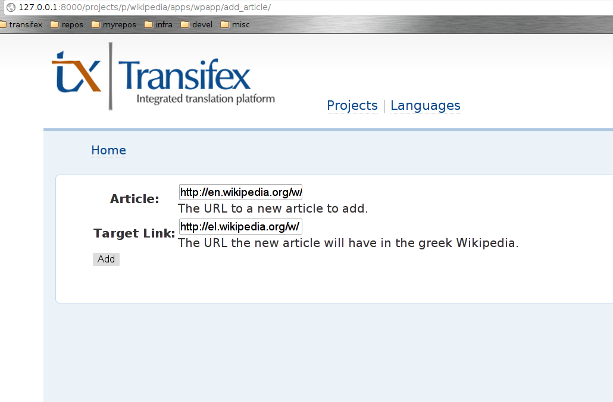Illustration 5.2: Add article page.
The project owner may also limit the access to the project. By default, any user of Transifex can translate articles. The project owner, however, may choose to accept translations only from users that have joined the teams of the project. Illustration 5.3 presents a screenshot of the configuration page.
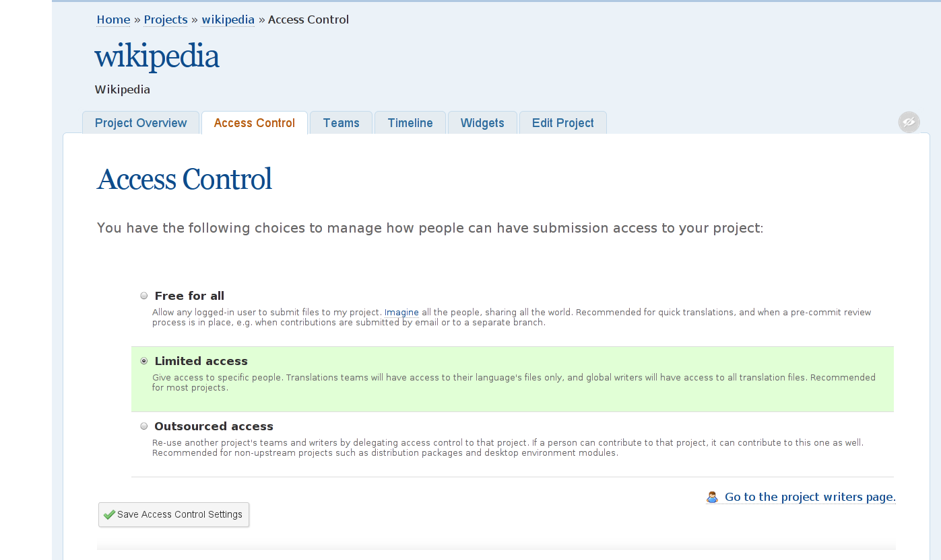Illustration 5.3: Access control page.

Translators

There is a user guide for translators, too. It is hosted at http://help.transifex.net/intro/translating.html#translating.
The user can translate any resource (article), although he may have to join the Greek project of the team first. The translation is done through lotte, Transifex's online editor. Illustration 5.4 has a screenshot of lotte (taken from https://www.transifex.net).
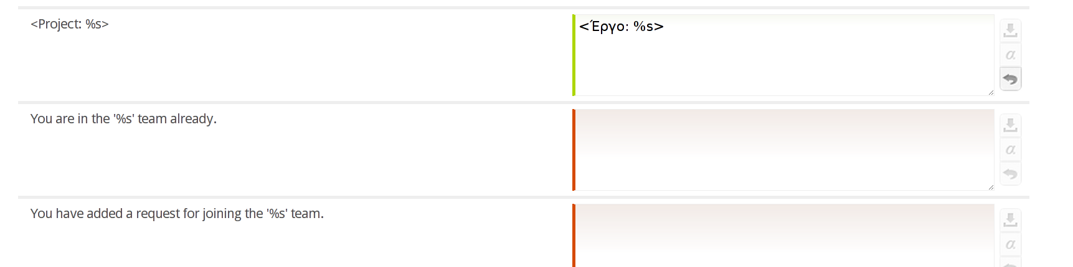Illustration 5.4: Translating resources in lotte.

